1. Login with your username and password in lowercase.

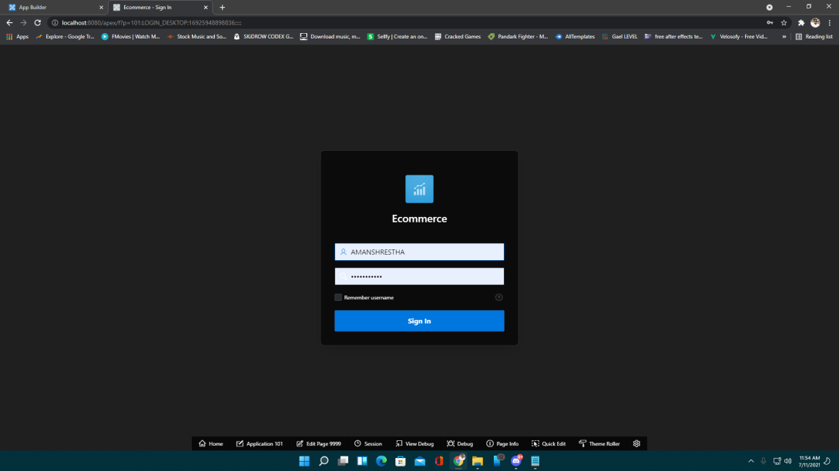

1. After login in with correct login details as Admin you’ll have access to the reports of all the traders, information of all customers , details of shop and products, information of highest sellers, and you can also view bunch of graph, pie-charts.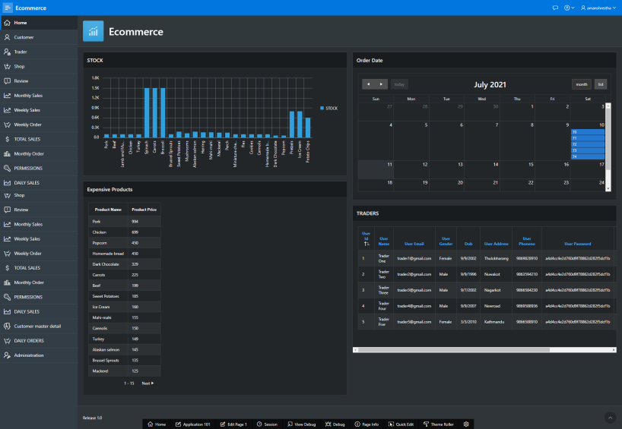
2. Admin can view the review and rating of the products given by the customer.

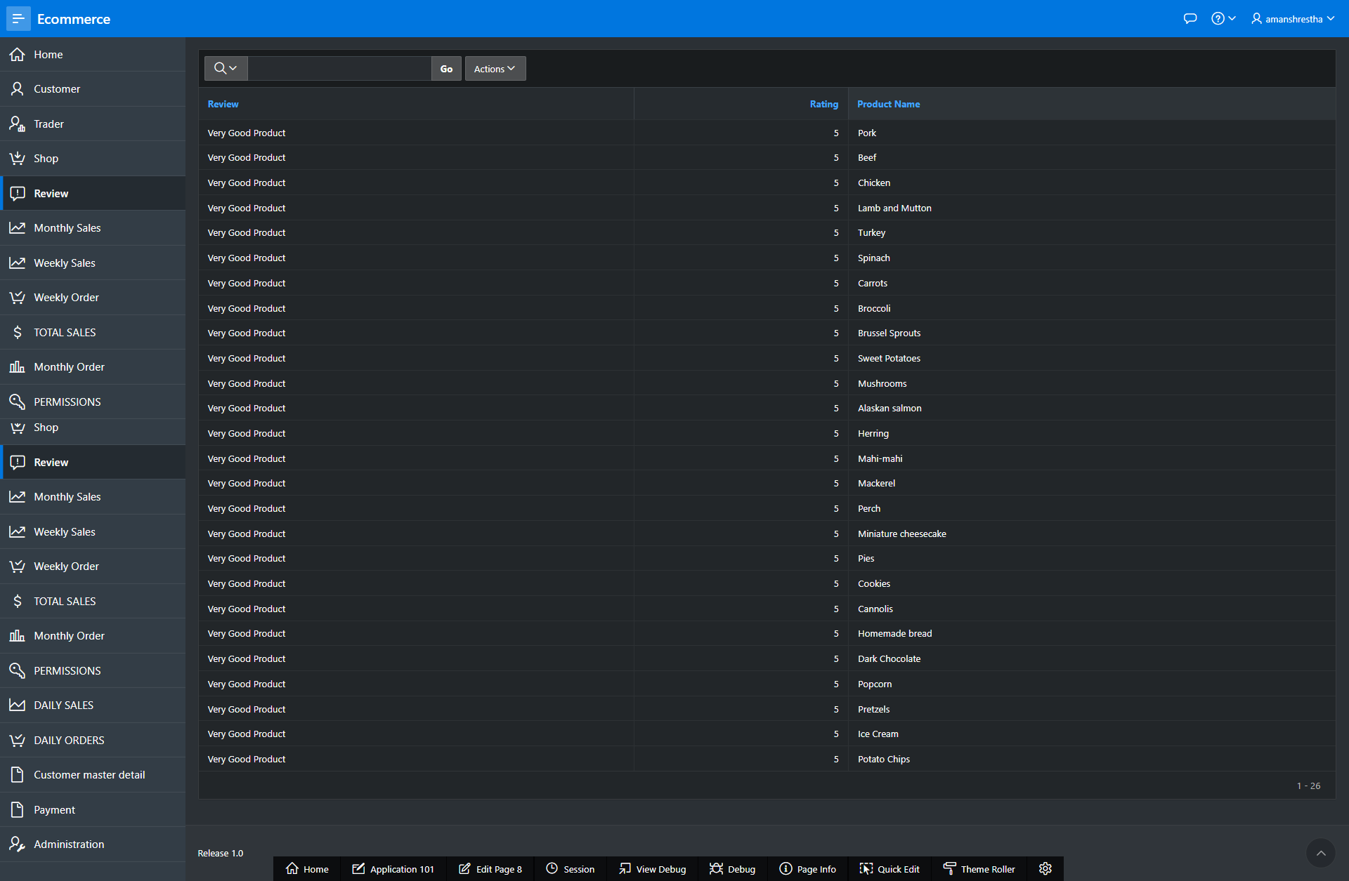

1. Admin can view the details of the customers.

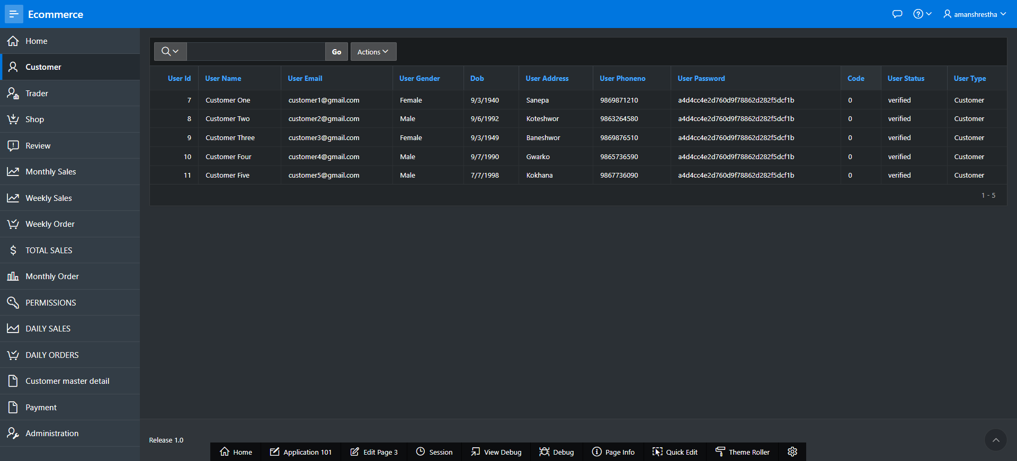

1. Admin can view the list of traders.

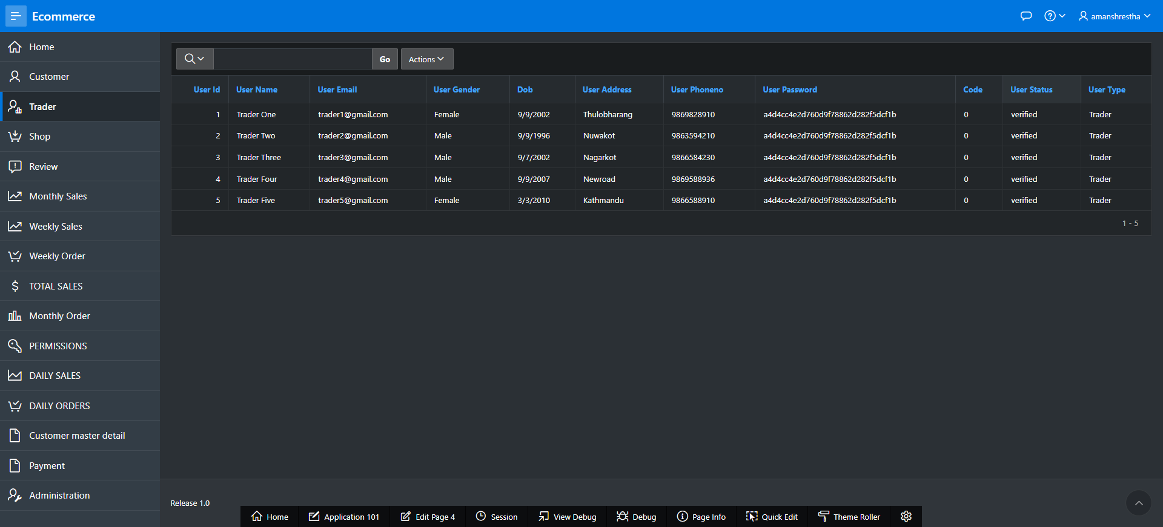

1. Admin can view the list of shops that traders own.

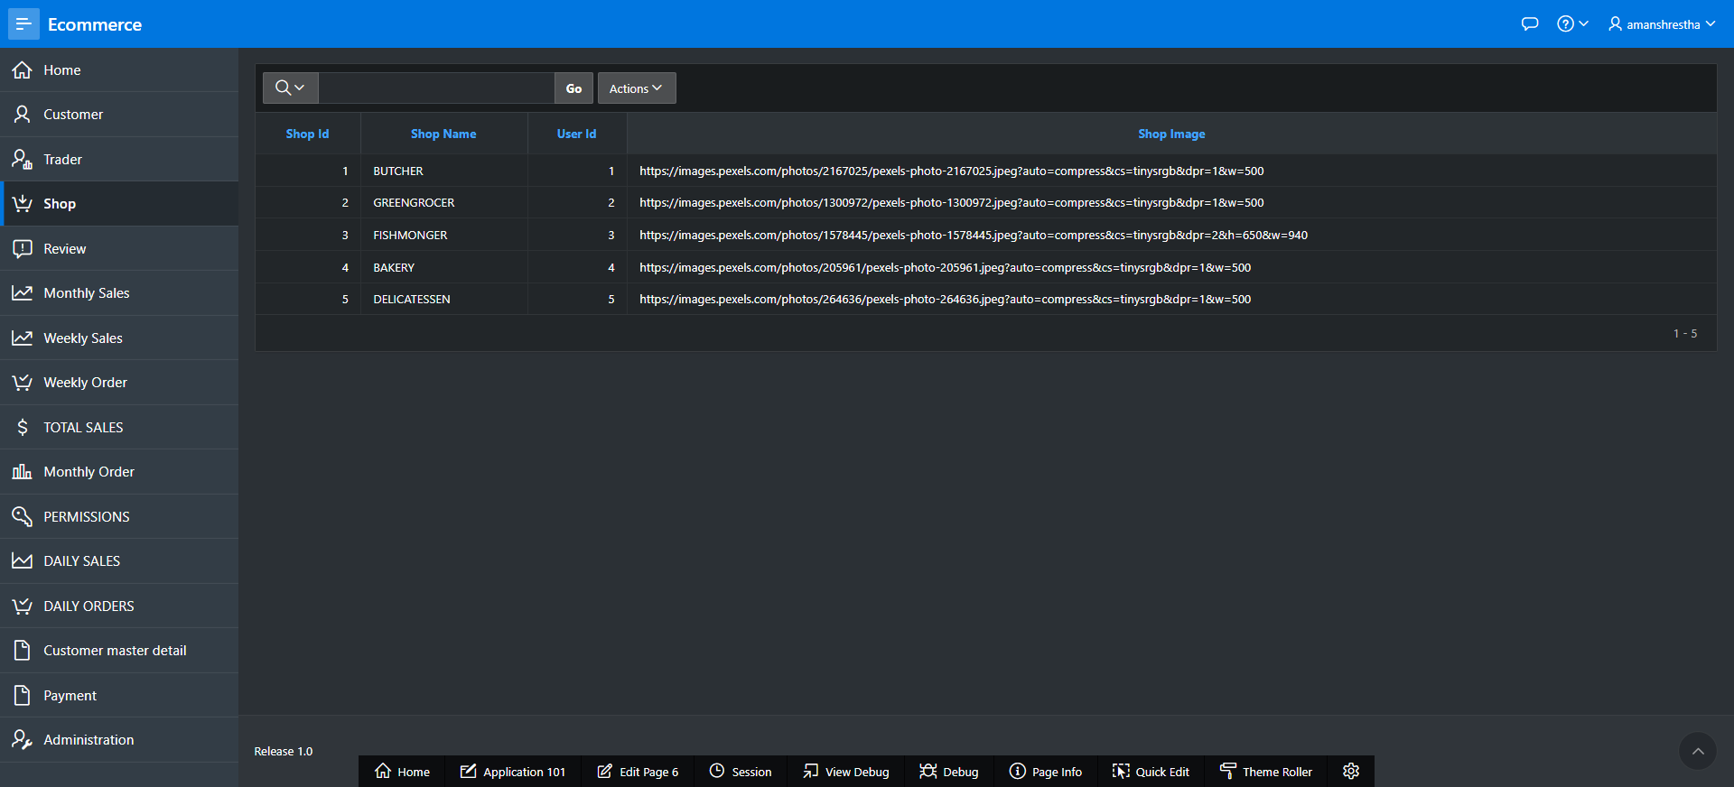

1. Admin can see the monthly sales. Monthly sales shows the product that are sold within in a month.

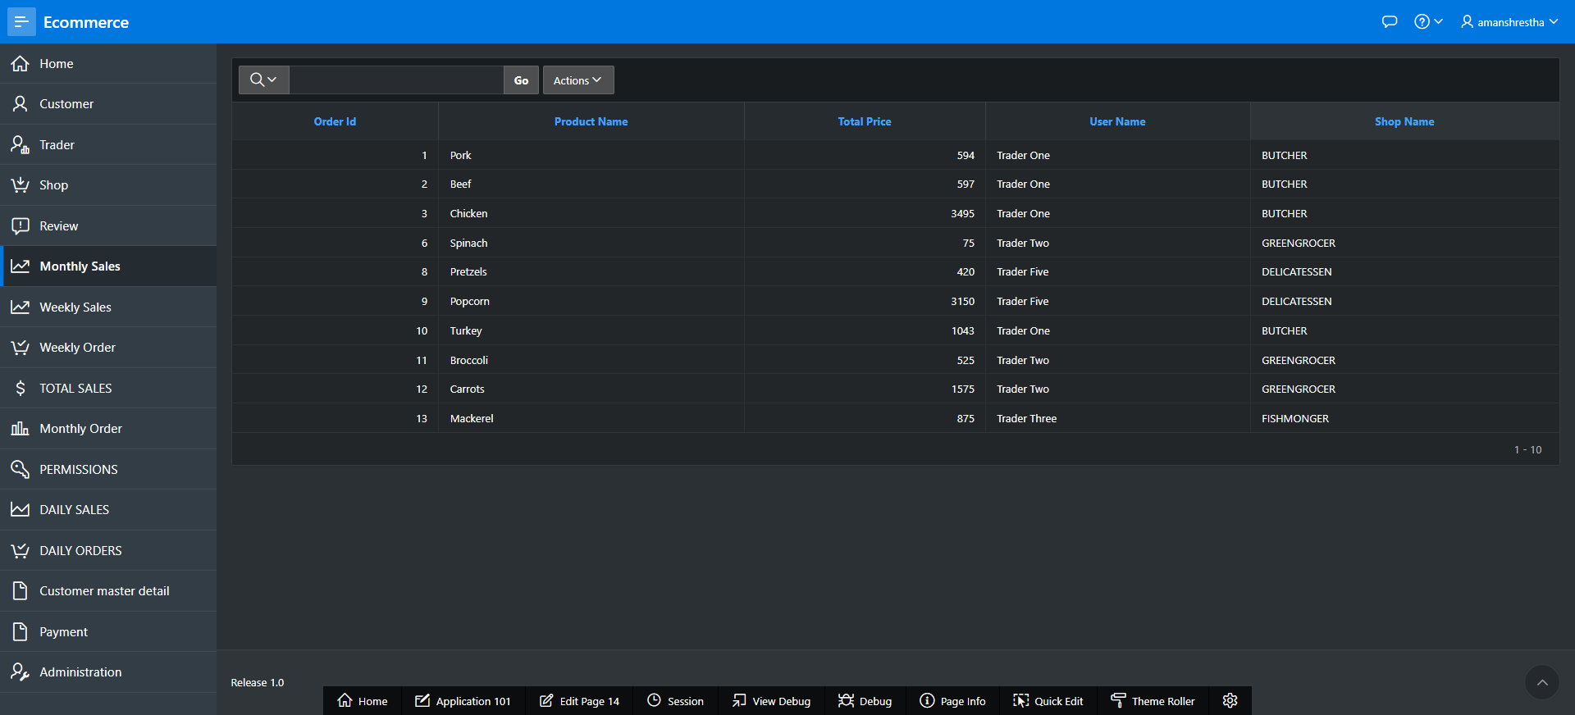

1. Admin can view weekly sales. Weekly sales report shows the product that are sold within a week.

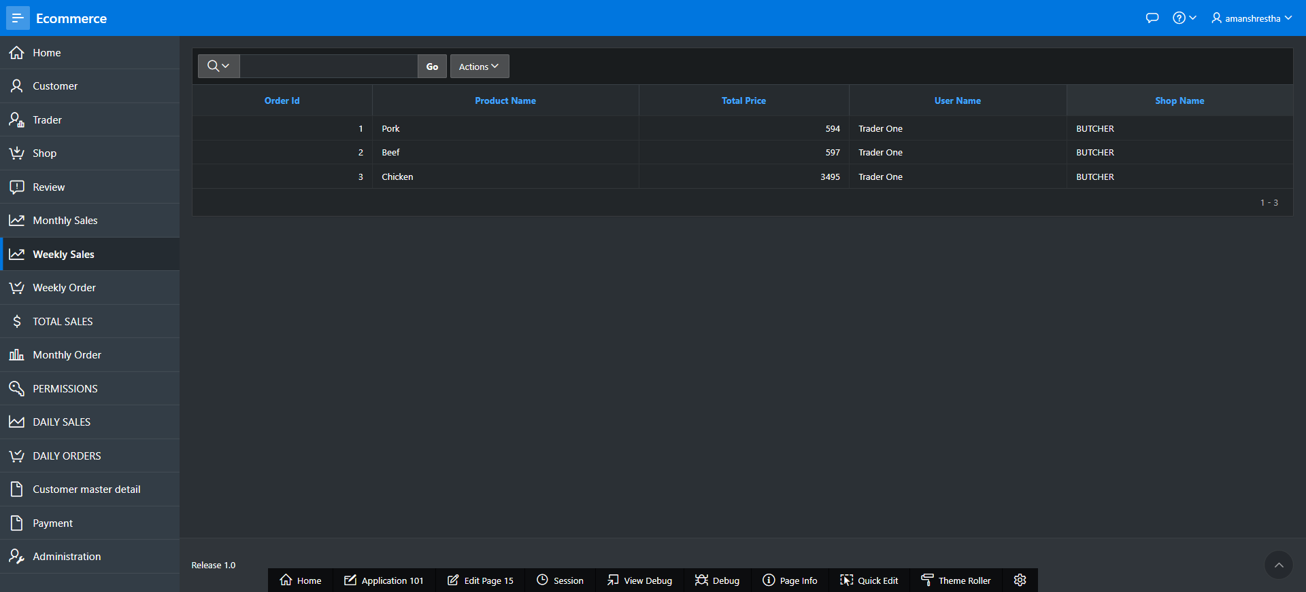

1. Admin can view total sales. Total sales shows the total prices of the product that are sold.

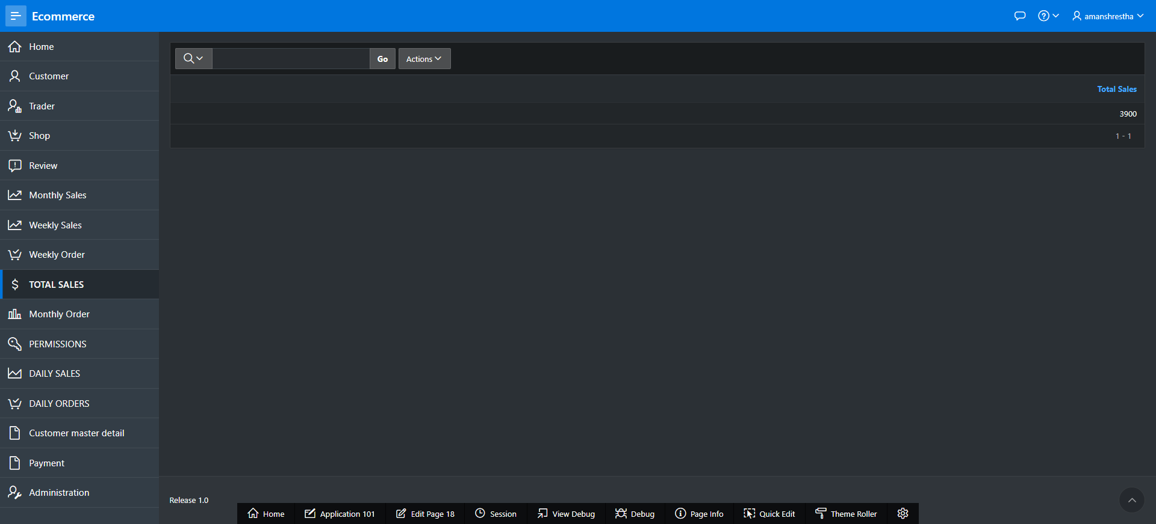

1. Admin can view weekly order. Weekly order shows the products ordered by customers within a week.

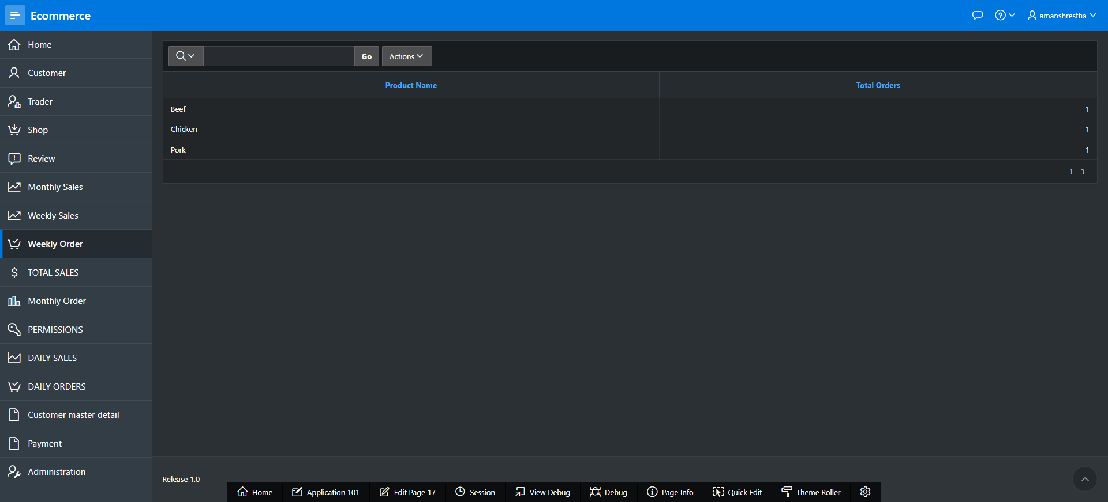

1. Admin can view the monthly orders. Monthly order shows the products ordered by the customers.

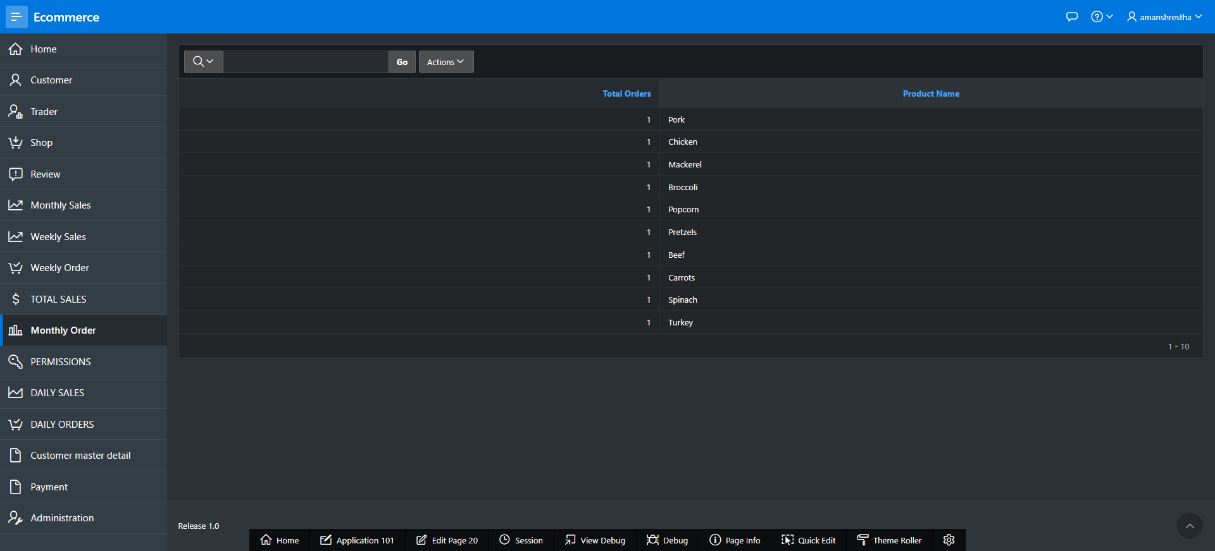

1. Admin can view daily sales. Daily sales shows the products that has been sold within 24 hour.

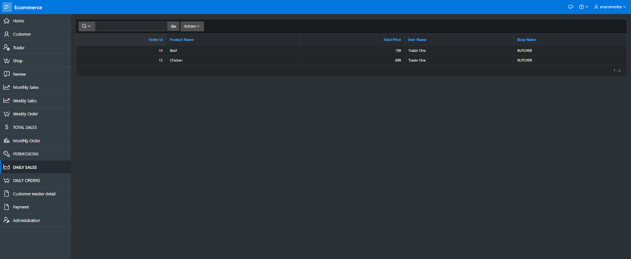

1. Admin can view daily orders. Daily orders shows the products that are ordered by the customers within 24 hour.

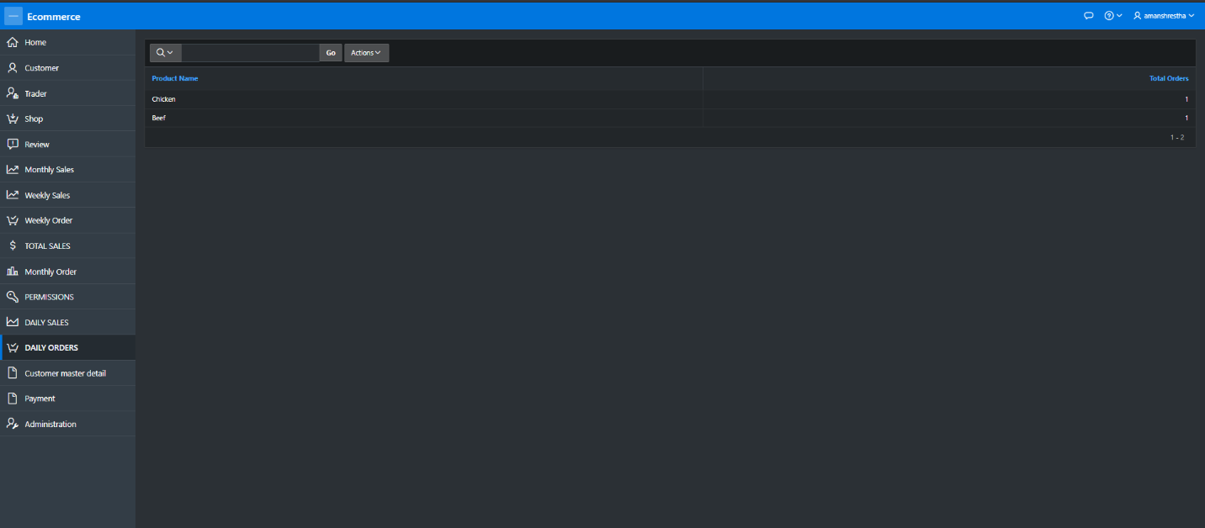

1. Admin can view payment details of the product with payment date, total amount of the product and the user ID.

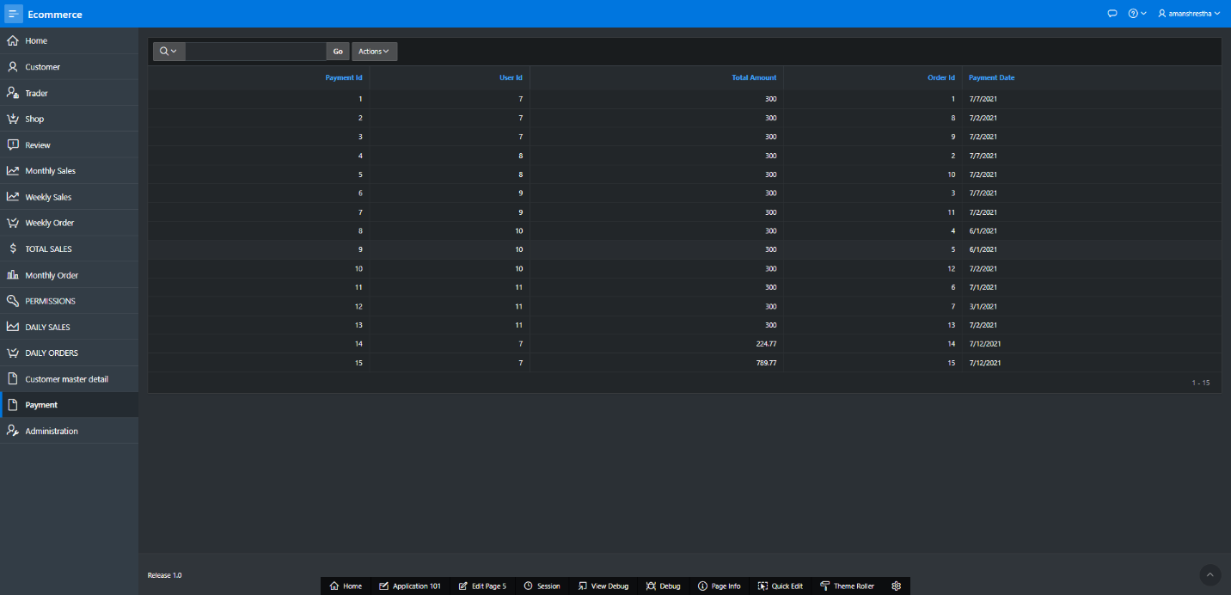

1. Admin can manage users. Admin can control user access.

